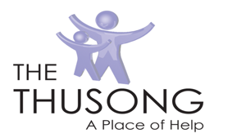 The Thusong Client Travel Questionnaire

The safety of our staff, clients, families and visitors remain The Thusong’s overriding priority. As the coronavirus disease 2019 (COVID-19) outbreak continues to evolve and spreads globally, The staff at TheThusong are monitoring the situation closely and will periodically update our company’s guidance based on current recommendations from the Centers for Disease Control and Prevention and the World Health Organization. To prevent the spread of COVID-19 and reduce the potential risk of exposure to our workforce and visitors, we are conducting a simple screening questionnaire. Your participation is important to help us take precautionary measures to protect you and everyone in this organization. Thank you for your time.

Client’s Name:
Client’s Primary Phone Number: | ( )

Self-Declaration by Client
1. | Have you been anywhere outside of the United States in the past 14 days?  YES____ NO____
2. | Have you had close contact with or cared for someone diagnosed with COVID-19 within the last 14 days?  YES____ NO____
3. | Have you been in close contact with anyone who has traveled outside of the United States within the last 14 days? If yes, where ______________________________  NO_______
4. | Have you experienced any cold or flu-like symptoms in the last 14 days (to include fever, cough, sore throat, respiratory illness, difficulty breathing)?  YES____ NO____

If the answer is “yes” to any of the questions, please contact The Thusong via email at thethusong@gmail.com or by phone at 443-739-4429 prior to coming to your next appointment.

